Francis Massen  francis.massen@education.lu  http://meteo.lcd.lu | 

Observed temporal and spatial CO2 variations useful for the evaluation of regionally observed CO2 data

Authors:
Francis Massen, Ernst Beck, Hans Jelbring, Antoine Kies

History:
version 1.0: original version 23Mar07
version 1.1: changed title
added decadal dependancy to calculations page 5, corrected error in latitude difference between Orleans and Mauno Loa (should be 28)
added table for clearness (p.6)
added remark on possible decadal oscillation in time dependancy (p.5)
corrected references (still uncomplete)
added a conclusion
added legends to figures

do be done: add explanation on Massen et al CO2/windspeed method?
use more data to compute CO2 gradient?

version 1.2.: 24 Mars07: added 3D plot
version 1.3.: 02 Apr07: complete rework to comply with the recommendations of Hans
emphasis more on latitudinal/seasonal/sea and land aspect
number of stations used is now 21

points to clear up:
circum polar vortex??? correct explanation for constant values?
should Francis loop and asymptotic wind model be discussed?
should more historic validitations be made?
points to be done: unique ocean-land correction (may be impossible)

version 1.3a 15Apr07: removed Orleans at lat=48 and added Pallas at lat=68
Orleans had same latitude as Schauinsland

version 1.3.b 17May07
rechecked calculations, now including Pallas/Finland
made missing graphs
added time dependance of latitudinal gradients
removed last example
20:30: corrected some obvious typos and one mistake
in the example

Abstract:

Observed ocean and land CO₂ data show both seasonal and spatial variations, where latitude is the most important in addition to the well known increase in time.. A simple, approximative corrective procedure is proposed which will be of use when comparing contemporary CO₂ data from land and ocean influenced stations and for the validation of historical CO₂ measurements

1. The variations of global CO₂ with latitude and time.

Figure 1 shows the global distribution of CO₂ as given by NOAA [7]:

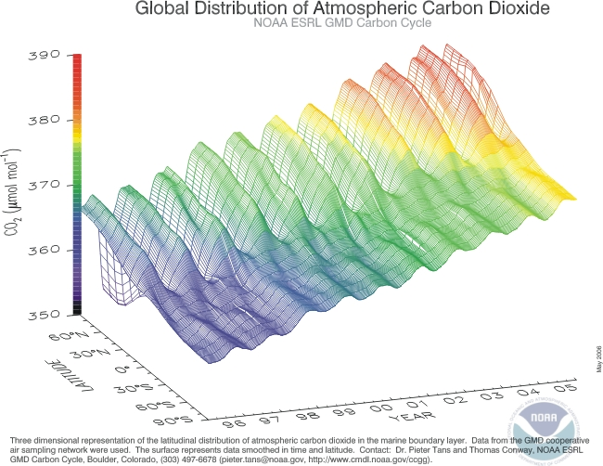

fig 1.Seasonal and latitudinal variation of CO₂ mixing ratios

Clearly CO₂ varies with time (continuous increase), season (high and low) and latitude. The aim of this paper is to find an easy approximative procedure to validate CO₂ measurements from different stations taken at the same time. The procedure should allow to handle differences in latitude, in location-type as sea- or land based, and in hemisphere. Thus it should be considered as a first step, before the application of full grown models like MATCH [7].

2. Stations and time-span used

All data in this study come from the NOAA Globalview ftp site at ftp://ftp.cmdl.noaa.gov/ccg/CO2/GLOBALVIEW/gv/ [1]
The data files hold 4 columns like:

Creation Date: Thu Aug 31 09:28:42 2006
# of rows after column header: 1297

UTC S(t) REF(t) diff
1979.000000 335.4340 336.7548 -1.3208
1979.020833 335.7970 337.1502 -1.3532

The CO₂ mixing ratio is S(t), or if not available the sum of REF(t) + diff.
23 stations from South-Pole to Spitsbergen are used in this study; start of the year (SOY) and mid of the year (MOY) data are from 1985, 1990, 1995, 2000 and 2005; with SOY corresponding to the yyyy.0000 and MOY to the yyyy.5000 records.
Ocean based stations are stations located at the cost coast or on an island; land based stations are at a distance from sea of at least 50km.

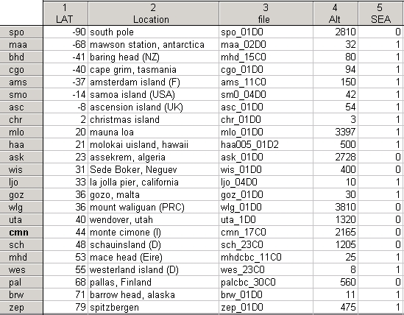

table 1: Stations used in this paper: SEA =1 means sea- or coast based station.

3. Stations of the southern hemisphere

A quick check shows that stations south of -40° latitude measure practically identical CO₂ mixing ratios and do not show any latitudinal gradient. The linear increase in time from 1985 to 2005 is 1.575 ppm*y⁻¹ (1.642 for the SOY, 1.504 for the MOYdata). Adjusting the MOY data for the 6 months delay from SOY shows only small (less than 1 ppm, except for 1985) positive and negative differences . This reflects the well known fact that the circumpolar vortex blocks or damps rapid and massive air mass intrusions from North to South; no major vegation cover also means there are no photosynthesis-driven seasonal forcings. .

The situation is different for the region between -40° and 0°.; the subset used in this study only has ocean based stations. The SOY and MOY data series both have positive latitudinal gradients, with of a mean 0.0392 +/-0.0093 for the SOY and 0.0622 +/-0.0168 for the MOY season.

Year | SH SOY  latitudinal  gradient | SH MOY latitudinal gradient
Year | Sea | Sea
1985 | 0.0303 | 0.0659
1990 | 0.0347 | 0.0455
1995 | 0.0363 | 0.0504
2000 | 0.0398 | 0.0604
2005 | 0.0547 | 0.0886
Mean  stdev | 0.0392  0.0062 | 0.0622  0.0168

table 2: linear regression slopes for SH stations and latitudes between -40° and 0°

The SOY latitudinal gradients increase with time, whereas the MOY gradients are more or less constant. An exception is the year 2005, where both gradients show an unusual large increase in respect to the preceeding year.

Figure 1 shows the linear regression lines.
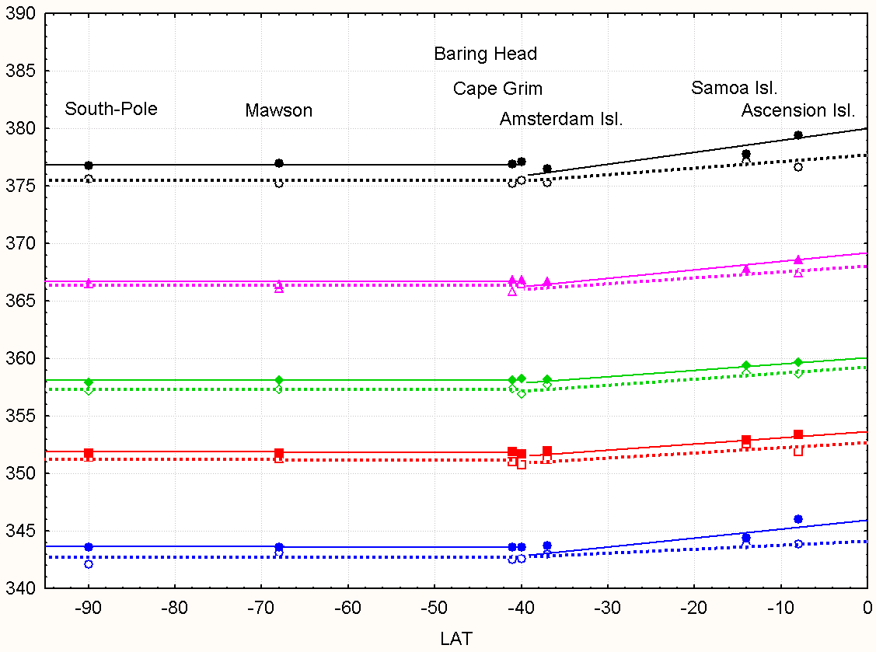
fig.2. Variations of SH CO₂ mixing ratios with latitude (SOY = hollow symbols and dotted lines , MOY = full symbols and lines ), 1985 to 2005.

The mean annual CO2 concentration increases for all SH stations are between 1.580 and 1.642 ppm* y⁻¹ ; at all stations except South-Pole MOY mixing ratios increase slightly faster than SOY ones.

location | latitude | Mean annual increase at SOY | Mean annual increase  at MOY
South-Pole | -90 | 1.642 | 1.624
Mawson | -68 | 1.580 | 1.628
Baring Head | -41 | 1.604 | 1.630
Cape Grim | -40 | 1.632 | 1.645
Amsterdam Island | -37 | 1.596 | 1.606
Samoa Island | -14 | 1.632 | 1.634
Ascension Island | -8 | 1.622 | 1.641
Mean/stdev for SH |  | 1.615  0.023 | 1.630  0.013
Mean/stdev for SH  latitude. >-40° |  | 1.617  0.019 | 1.627  0.019

table 3: compared SOY and MOY annual linear increases for SH, 1985-2005

The difference between same year SOY and MOY observations is small if the MOY data are corrected for the 6 months delay by substracting 0.815. ( see table 4 for the year 2005 situation).
location | latitude | SOY | Time-delay adjusted MOY | delta  ppm
South-Pole | -90 | 375.6 | 376.0 | 0.4
Mawson | -68 | 375.2 | 376.2 | 1.0
Baring Head | -41 | 375.2 | 376.0 | 0.8
Cape Grim | -40 | 377.1 | 376.3 | 0.8
Amsterdam Island | -37 | 375.3 | 375.9 | 0.6
Samoa Island | -14 | 377.1 | 377.0 | 0.1
Ascension Island | -8 | 379.4 | 378.6 | 0.8
table 4: SOY and delay corrected MOY data are very close (year 2005).
Conclusion: To validate SH CO₂ data for latitudes higher than -40° an approximate latitudinal gradient of 0.04 ppm*degree⁻¹ for the SOY and 0.06 ppm*degree⁻¹ for the MOY period is suggested. Stations located below -40° latitude do not need to be corrected. The increase with time is approx. 1.6 ppm*y⁻¹ for all SH stations.
The small difference between SOY and MOY readings shows that SH stations do not have a large seasonal effect. The maximum difference caused by the latitudinal gradient is 2.4 ppm for the most distant stations.

4. Stations of the Northern Hemisphere

The simple SH situation becomes more complicated in the NH due to much greater landmasses and vegetation. 16 stations, 9 sea and 7 land based are used in this study. The paucity of land-based stations represents a real problem, as there exists no ensemble of evenly spaced land stations.. We use land stations between latitude 23° (Assekrem, Algeria) and 68° (Pallas, Finland).
As shown in table 5, the SOY latitudinal gradients all are positive and higher than the corresponding SH gradients; the gradient for land stations are up to 2 times higher than those of the sea based stations .
The MOY trends are negative for all sea and land-based stations; land stations have negative gradients 6 to 18 times higher than sea stations! This big change clearly shows the importance of making a difference between land and ocean based stations during the summer periods: if in a first approximation SH sea and land stations of the same latitude could be treated in a similar manner, the huge difference of the latitudinal influence during the summer season makes that distinction mandatory for NH stations. During the NH winter season the difference becomes smaller with the land gradients practically the double of the sea gradients. The similar magnitude of the negative MOY land gradients and the positive SOY sea gradients shows that summer-time land regions are as much a CO₂ sink as winter sea regions are a source.

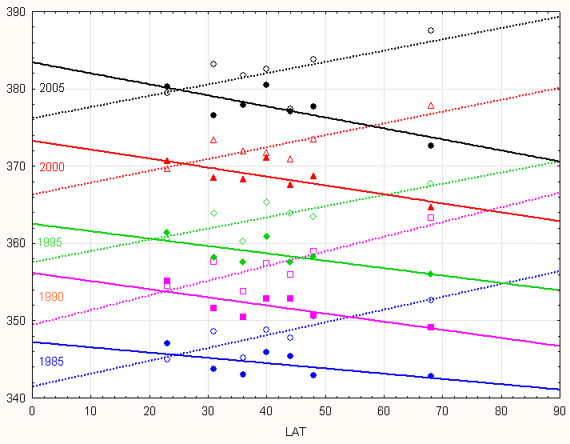
fig.3. Variations of NH land station CO₂ mixing ratios with latitude (SOY = hollow symbols and dotted lines , MOY = full symbols and lines ). 1985 to 2005

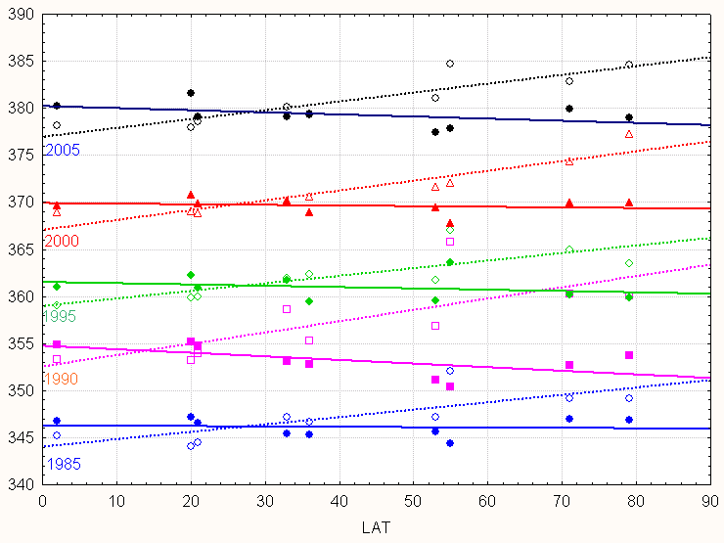
fig.4. Variations of NH sea stations CO₂ mixing ratios with latitude (SOY = hollow symbols and dotted lines , MOY = full symbols and lines ). 1985 to 2005

The magnitude of negative MOY gradients of the sea stations remain more or less constant with time, whereas the latitudinal gradients of land stations change remarkably (trend is -0.0032 per year), and suggest a rising summertime CO₂ uptake in the more northern regions , possibly due to an ongoing greening of the northern NH land-masses.

Year | NH SOY latitudinal gradient |  |  | NH MOY latitudinal gradient
Year | Sea | Land | L/S | Sea | Land | L/S
1985 | 0.0786 | 0.1656 | 2.1 | -0.0038 | -0.0683 | 18.0
1990 | 0.1200 | 0.1899 | 1.6 | -0.0146 | -0.1051 | 7.2
1995 | 0.0804 | 0.1450 | 1.8 | -0.0139 | -0.0957 | 6.9
2000 | 0.1044 | 0.1534 | 1.5 | -0.0067 | -0.1159 | 17.3
2005 | 0.0940 | 0.1459 | 1.6 | -0.0225 | -0.1426 | 6.3
Mean  stdev | 0.0955  0.0173 | 0.1600  0.0187 | 1.7  0.2 | -0.0123  0.0073 | -0.1055  0.0272 | 11.1  6.0

table 5: SOY and MOY latitudinal gradients for the NH

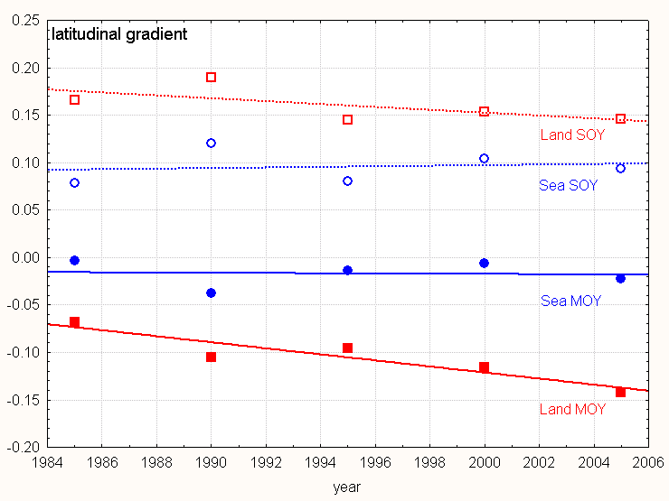
fig. 5. Time dependancy of NH latitudinal gradients (MOY = solid, SOY = dotted lines)

As the latidudinal temperature drop becomes greater during the winter season, one should expect a high negative trend for the sea stations during winter-time, and a positive one during summer-time. The data show the opposite: the positive trend may be caused by a predominance of the massive wintertime land sources which flips a "natural" trend from negative to positive and vive-versa. The magnitude of the winter sea and land stations latitudinal gradients differs by a factor 2, the sea gradient being always smaller than the corresponding land gradient.

The gradients from table 5 may be compared to those reported in [6] for the total CO2 column measured during a ship cruise in Jan/Feb 2003, where the authors report a variation of about 1.3 ppm between 0° and 10° latitude; their measurements at higher latitudes give a negative gradient, opposite to this study and the MATCH model used by the authors. This paper clearly shows that a single trip from one hemisphere to the other can not yield a correct estimation of the latitudinal gradient.

To estimate the seasonal amplitude for 2005, we will adjust the MOY data by substracting 0.82, as the yearly increase for all stations of the NH is about 1.64 ppm*y⁻¹:

Location | Lat.  ° | Alt.  masl | Sea or Land | SOY | Time-delay adjusted MOY | delta
Christmas Island | 2 | 3 | Sea | 378.1 | 379 | 0.9
Mauna Loa, Hawaii | 20 | 3397 | Sea | 378.0 | 381 | 3.0
Molokai Island, Hawaii | 21 | 500 | Sea | 378.6 | 378 | 0.6
Assekrem, Algeria | 23 | 2728 | Land | 379.5 | 379 | 0.5
Sede Boker, Israel | 31 | 400 | Land | 383.1 | 382.3 | 0.8
La Jolla, USA | 33 | 10 | Sea | 380.1 | 378 | 2.1
Gozo, Malta | 36 | 30 | Sea | 379.4 | 378 | 0.6
Mount Waliguan, PRC | 36 | 3810 | Land | 381.8 | 377 | 4.8
Wendover, UT, USA | 40 | 1320 | Land | 382.5 | 380 | 2.5
Monte Cimone, Italy | 44 | 2165 | Land | 377.4 | 376 | 1.4
Schauinsland, Germany | 48 | 1205 | Land | 383.8 | 377 | 6.8
Mace Head, Ireland | 53 | 25 | Sea | 381.0 | 377 | 4.0
Westerland, Germany | 55 | 8 | Sea | 384.7 | 377 | 7.7
Pallas, Finland | 68 | 560 | Land | 387.5 | 371.8 | 15.7
Barrow, AL, USA | 71 | 11 | Sea | 382.8 | 379 | 3.8
Spitsbergen, Norway | 79 | 475 | Sea | 384.6 | 378 | 6.6

table 5: Difference between SOY and MOY mixing ratios.

As can be observed, the seasonal difference is small for isolated islands (Christmas, Gozo) and desert locations (Assekrem , Sede Boker). It is higher in vegetation rich locations as Schauinsland and especially Pallas (large surrounding forests). Westerland island is very close to the mainland, and shows similar seasonal behaviour. Spitsbergen with its much shorter summer season comes a bit as a surprise; the important seasonal swing might be a spill-over from the inflow of large easterly land-based winter sources.

5. How to apply a seasonal and latitudinal correctors

The stations in this report were different according to land or sea locations, SH or NH hemisphere, latitude and period of the year. Our report shows that the sole qualifier of sea- or land-based does not point to a clear applicable different seasonal correction, as the seasonal gradients rises from negligeable to important in a comparable manner when going from South to North. NH Southern stations located in arid regions do not differ much from sea stations at the same latitude; and this holds even for more northern locations. An exception are large forrest area stations as Pallas.

The situation is easy for SH stations located lower then -40°: no correction is needed! For the SH stations located between -40° and the equator, correctors as +0.04 ppm per degree and +0.06 ppm per degree are suggested for the SOY and MOY seasons. As a first check, one could even neglect the seasonal difference and retain a single latitudinal gradient of 0.05 ppm per degree for all seasons.

For the NH the seasonal latitudinal gradient remains the most important corrector. Four different situations should be respected:

sea and SOY: +0.096 ppm per degree
sea and MOY: -0.012 ppm per degree
land and SOY: +0.160 ppm per degree
land and MOY: -0.110 ppm per degree

Ideally only stations of the same type should be compared; when this is not possible, use the correct sea/land latitudinal gradient and apply a best guest corrector for extremely different locations (cost/sea and forrest covered mainland).

5. Applying the correction to a historical data series

As an example, we will use the measurements done by Steinhauser in Wien during the Mai-August 1957 [2] .This is one of the few well documented chemical measurement series overlapping with the first NDIR measurements by Keeling..

To compare with the first Keeling measurements, we will use the results from fig.5. Keeling made early measurements at Mauna Loa, lat. 20°, in 1958; the July mixing ratio is 313 ppm.. The latitude of Wien is 48°; applying the gradient to the Keeling data gives the following results

Steinhauser, Wien, July 1957 (mean) : 319 ppm (from [2])
Keeling, Mauna Loa, July 1958: 313 ppm (fig. 5)
MLO MOY sea latitude correction: 28*-0.01 = -0.3
-------------------------------------------------------------------------------------------------------
adjusted MLO 313 -0.3 = 312.7 ppm = result if Keeling
had measured at the latitude of Wien
subtract increase for 1 year difference
between time of measurements 1.6 (estimated)
-------------------------------------------------------------------------------------------------------
definitive adjusted MLO: ~311 ppm (no other sea/land correction)
difference between chemical and NDIR measurements: 8 ppm =~2.6%
A further problem comes from the fact that the whole MLO annual cycle is time-shifted by about 3 months versus Wien (Wien minima happen in June, MLO minima in Sept-Oct.
If we compare a full yearly cycle from Wien (mean of Jan57 to Dec 57:320 ppm) to the May58 to April58 MLO mean (313 ppm), the difference becomes ~10 ppm (+3.2% relative to MLO) after applying the latitudinal ( -0.3)and time (- 2.4) corrections to the MLO readings..

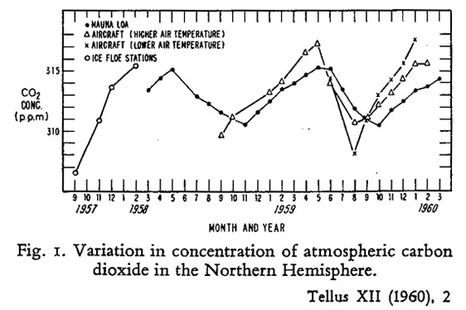
fig.5 The early Keeling curve (from Scripps Institution of Oceanography)

6. Conclusion:

This report shows the importance in applying latitudinal and seasonal correctors when comparing or validating CO₂ data from different stations. For SH stations, the latitudinal gradient is the sole corrector needed. For NH stations of the same sea/land type one can use one of the 4 mean gradients from table 5, according to SOY, MOY, SH and NH. If the stations belong to different sea-land categories, the comparison is hampered by the uncertain magnitude of the sea/land corrector.

References:

1. GLOBALVIEW-CO2: Cooperative Atmospheric Data Integration
Project - Carbon Dioxide. CD-ROM, NOAA/CMDL, Boulder, Colorado.
[Also available on Internet via anonymous FTP to ftp.cmdl.noaa.gov,
Path: ccg/CO2/GLOBALVIEW], 2006.

2. Steinhauser F., Der Kohlendioxyd-Gehalt der Luft. DK 551.510.41

3. The early Keeling Curve. http://scrippsCO2.ucsd.edu/program_history/early_keeling_curve_2.html

4. Beck E., 180 Years of Atmospheric CO2 Gas Analysis by Chemical Methods.
ENERGY & ENVIRONMENT; VOLUME 18 No. 2 2007

5. Warneke T. et al: Seasonal and latitudinal variations od column averaged volume-mixing ratios of atmospheric CO2. GRL, vol.32, L03808

6: MATCH model: http://www.cgd.ucar.edu/cms/match/new_website/

7. NOAA

